173

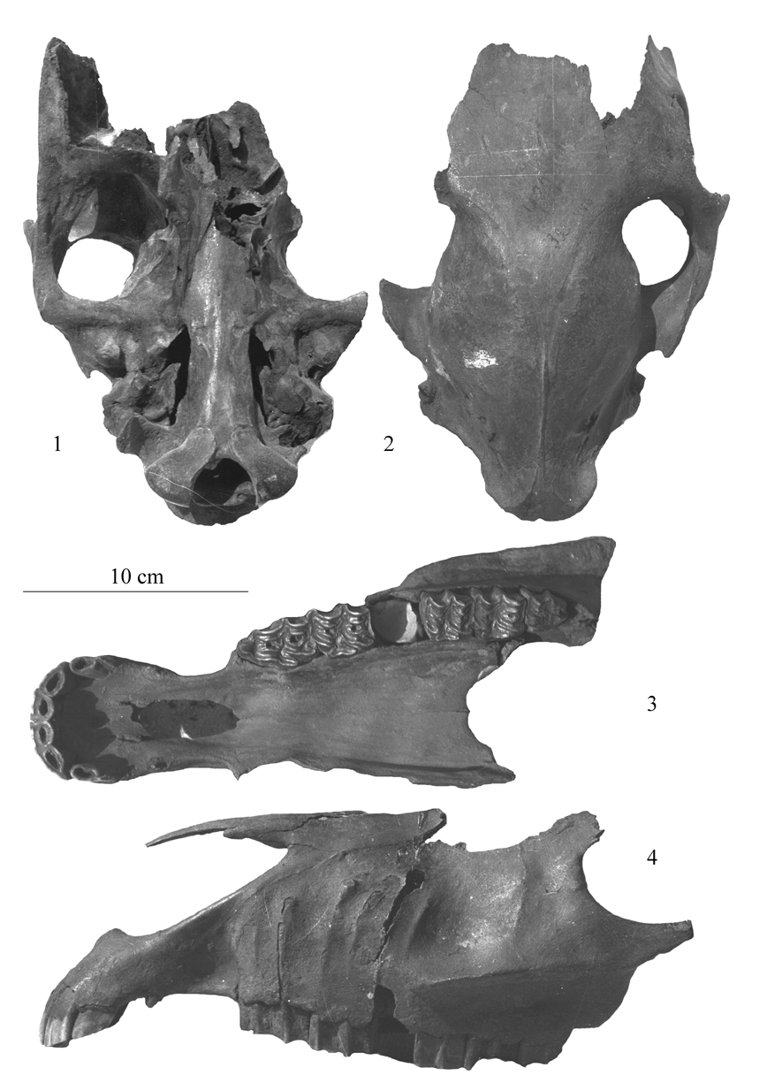

Figure 14. E. binagadensis skulls. 1-2: PIN 395-446, ventral and dorsal views. 3-4: PIN 395-453 and 448, ventral view and profile.

174

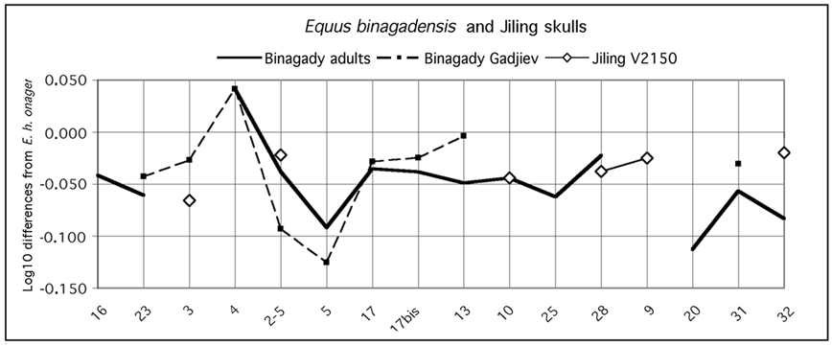

Figure 15. Ratio diagrams of Binagady and Jiling skulls. Measurements are given in Table 1.

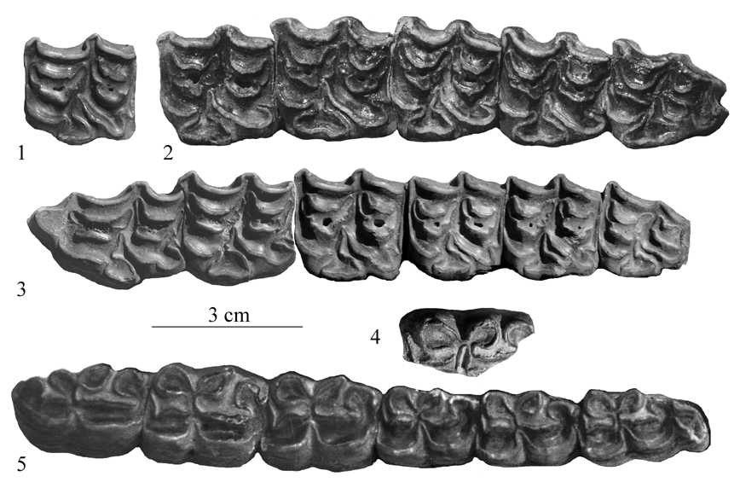

Figure 16. E. binagadensis cheek teeth. 1: TB 222, upper P3 or P4. 2: TB 222', upper P3-M3. 3: PIN 395-454-2, upper P2-M3. 4: PIN 399-126, lower molar. 5: PIN 395-458, lower P2-M3.

175

One upper premolar (with a very short protocone (Fig.16-1) and one lower molar with a deep ectoflexid (Fig.16-4), as well as a few limb bones were tentatively referred to E. hydruntinus. It is, however, possible that they also belong to E. binagadensis.

The metapodials (Fig.17) do not resemble extant hemiones (Fig.5) or E. hydruntinus (Fig.11-12).

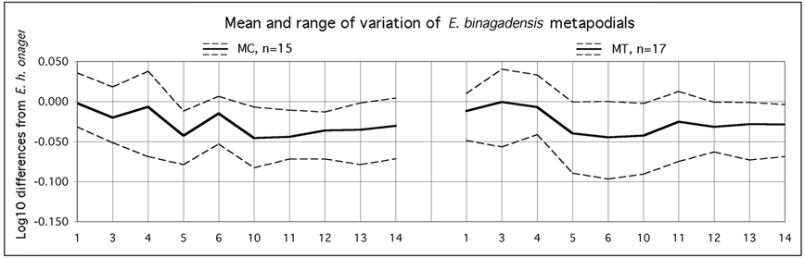

Figure 17. Ratio diagrams of E. binagadensis third metacarpals (MC III) and metatarsals (MT III). Data in Tables 3-4 and Eisenmann & Mashkour (1999).

3. Kurtak, South-Central Siberia

Inside Late Pleistocene sediments of the North-Minusinsk Basin (Foronova 2006) were found hemione-like metapodials but no other bones or teeth. The MC III are very polymorphic. The MT III are extremely deep both in the diaphysis (4) and at the proximal end (Fig.18).

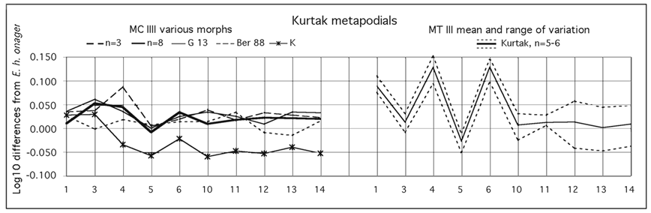

Figure 18. Ratio diagrams of Kurtak third metacarpals (MC III) and metatarsals (MT III). Data in Tables 3-4.

4. Sjara-osso-gol, Ordos, Mongolia

Boule and Teihard de Chardin (1928) described a subadult associated skeleton (mounted at the Museum of Paleontology in Paris), two other skulls, and some limb bones belonging to hemiones from the middle or late Paleolithic of Sjara-osso-gol. Unfortunately, the skulls are not well preserved and belong to juvenile or subadult

176

animals. The best skull (part of the mounted skeleton) is about the size of extant kiang and dziggetaj (Fig.19).
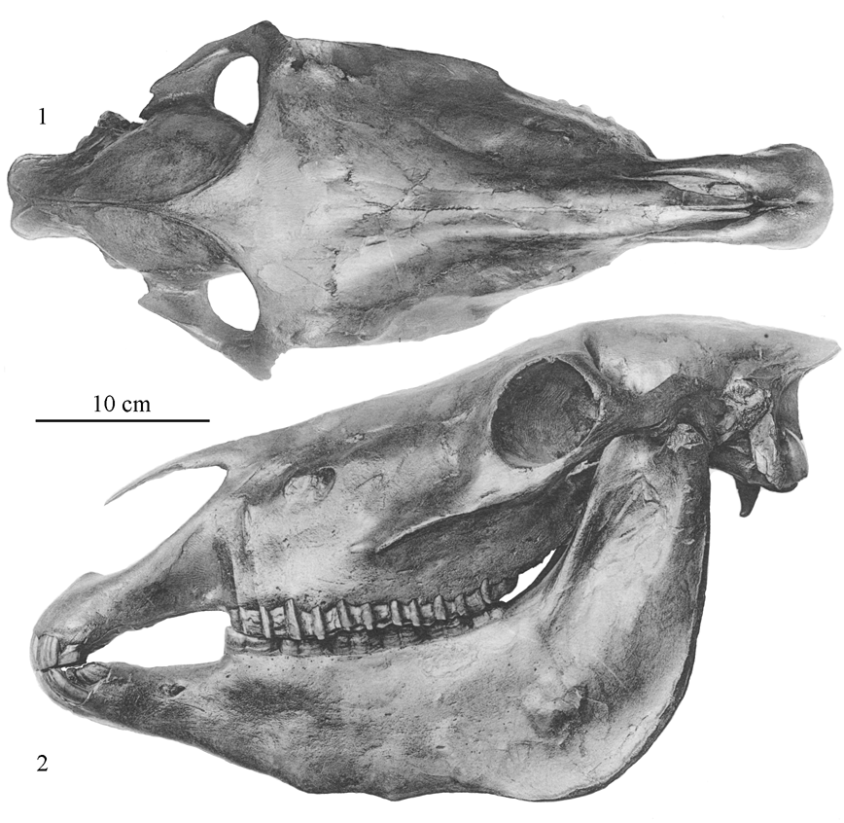

Figure 19. Mounted skeleton skull from Sjara-osso-gol. Dorsal and profile views adapted from Boule & Teilhard 1928.

The upper and lower cheek teeth are typical of hemiones: pli caballin small or absent, deep post-protoconal valleys on the upper; elongated metaconids, very shallow linguaflexids and ectoflexids on the lower (Fig.20).

177

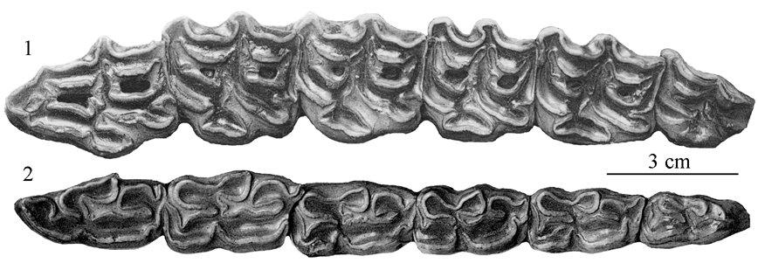

Figure 20. Upper and lower cheek teeth from Sjara-osso-gol. Occlusal views adapted from Boule & Teilhard 1928.

There are some questions about the real association of the phalanges of the mounted skeleton. The major part of the material is unavailable for study. As much as may be guessed from the associated skeleton, the limb segment lengths (Fig. 9 and 10) present some resemblances with E. hydruntinus.

The MC III (Fig.21) we were able to study are rather like those of E. hydruntinus (Fig.11), but not the MT III which rather resemble those of Kurtak (Fig.18).

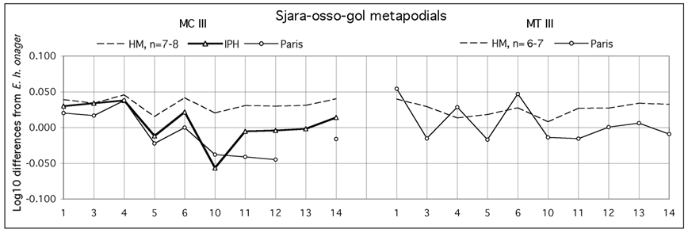

Figure 21. Ratio diagrams of third metacarpals (MC III) and metatarsals (MT III) from Sjara-osso-gol compared to extant E. hemionus hemionus HM. Measurements in Tables 3-4. n=number of specimens.

5. Loufangzi, Huanxian, Gansu, China

Numerous teeth, mostly isolated, and a few limb bones (Deng & Xue 1999) are preserved in the Department of Geology of the Northwest University, Xi'An, Shaanxi, China. Even putting aside a few teeth of large size which may belong to a caballine, the variability is great. In some upper cheek teeth the post-protoconal valley is shallow (Fig.22-2, 6), and a pli caballin may be present (Fig.22-5). Protocones vary from very short (Fig.22-7) to very long (Fig.22-2, 10, 11). On the whole, the teeth illustrated in Fig.22-2, 5, 6, 12 do not look hemione-like. One interpretation may be that the variability

178

does not only result from temporal heterogeneity but also from environmental stress: there are several teeth (as Fig. 22-1 and Fig.23-4) showing hypoplasia on their crown.

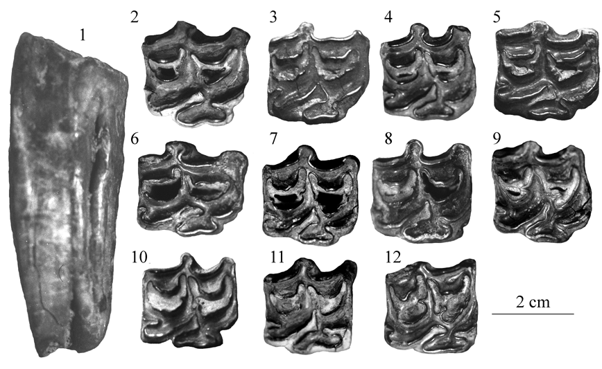

Figure 22. Upper cheek teeth from Loufangzi. 1: P3 or P4, 840. 2:-P3 or P4, -87. 3: P3 or P4, 867. 4: P3 or P4, 824. 5: P3 or P4, 964. 6: P3 or P4, 804. 7: M1 or M2, 817. 8: M1 or M2, 816. 9: M1 or M2, 801. 10: M1 or M2, 819. 11: M1 or M2, M 63111. 12: M1 or M2, 818.

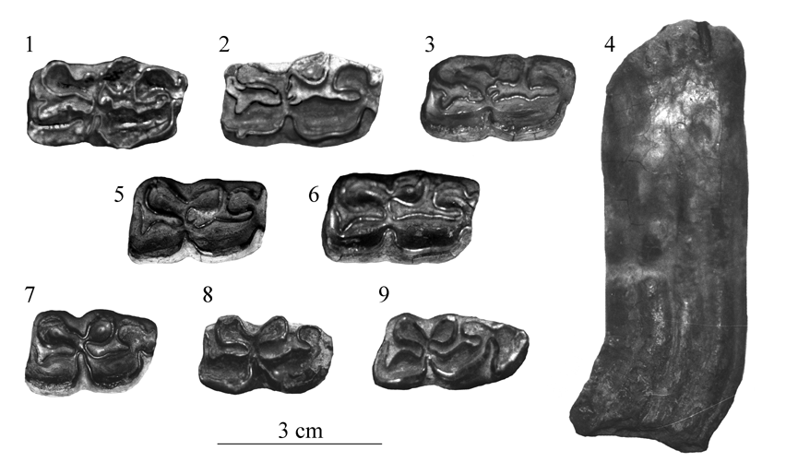

Figure 23. Lower cheek teeth from Loufangzi. 1: P3 or P4, 9106. 2: P3 or P4, 9141. 3: P3 or P4, 9181. 4: M3, no number. 5: P3 or P4, 9145. 6: P3 or P4, 9147. 7: M1 or M2, 975. 8: M1 or M2, 8119. 9: M3, 8128.

179

The lower cheek teeth also vary in size (compare Fig.23-1, 2, 3, 6 to 7) and in the shape of the double knot: shallow linguaflexid on Fig.23-2, bridge on 1 and 3, pointed linguaflexid on 6 and 9.

Variation in size and shape appears also on the metapodials (Fig.24).

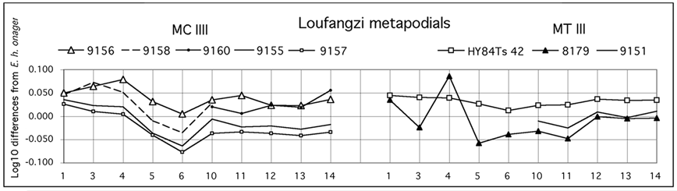

Figure 24. Ratio diagrams of Loufangzi third metacarpals (MC III) and metatarsals (MT III). Data from Deng & Xue 1999.

6. Yushu, Jiling, China

A few hemione fossils, preserved at the Institute of Vertebrate Paleontology, Beijing, China, including a fragment of skull, V 2150 (Fig.15 and 25). The skull and the dentition are small, quite smaller than those of Sjara-osso-gol. The profile is ram-nosed, unlike at Sjara-osso-gol. The muzzle was probably short and very wide.

The right and left upper premolars are quite different from each other (Fig.26).

The single MT III (V 2179) is very large (Fig.29 right) and cannot belong to the same form.

